1. Difference between window and document objects in Javascript

| **Window Object** | **Document Object** |
| --- | --- |
| * Window is at a root/top level at the JavaScript object hierarchy. * Global/root object in JavaScript. * It is the root object of the Document object model(DOM). | * A document is an object inside the window object * Document object is used to do manipulation inside the document. |
| Syntax: window.propertyname; | Syntax: document.propertyname or  window.document.propertyname |
| We can access document object properties inside the window. | We can not access windows objects properties inside the document. |
| Browser Object Model (BOM) | Document Object Model(DOM) |

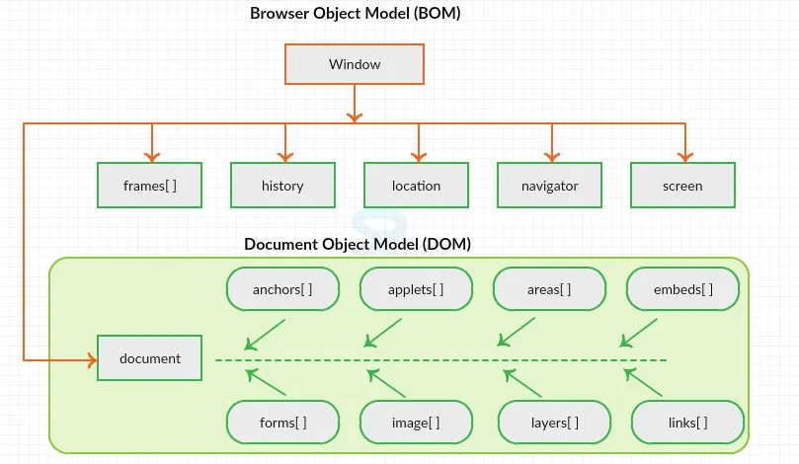

1. Codekata practice - Done